**Properties of Steam**

**PROPERTIES OF STEAM**

# Steam

Vapor form of water is called STEAM.

* + - Water in solid phase: We call it as ICE
    - Water in liquid phase: We call it as WATER
    - Water in gaseous phase: We call it as STEAM

# Application of steam

* + - Food processing industry.
    - Cooking: hotels, restaurants etc.
    - Used as a working fluid in steam engines and steam turbines.
    - Used in industries for process heating.
    - Petrochemical industry.
    - Washing / drying / sterilizing in hospitals.
    - Health clinic / gym.

# Formation of steam experiment at constant pressure

The action of heat in the formation of steam from water is illustrated in the Fig.1.2 shown below. As the steam is continuously generated, its pressure gradually increases and is supplied from the boilers to the engines or turbines at constant pressure. To know the values of the various properties of steam at a particular pressure, a steam generation experiment is conducted by heating water from 0oC at a given constant pressure. Since the steam is generated at constant pressure, the amount of heat energy supplied to convert the water into steam will be equal to its enthalpy.

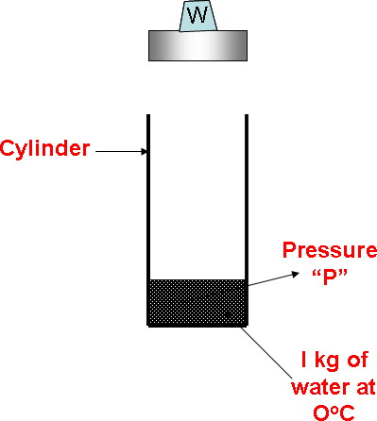

Fig. 1.1

Consider 1 kg of water at 0oC taken in a cylinder fitted with a freely moving frictionless piston as shown in Fig*.*

1.1. A chosen weight is placed over the piston so that the total weight of the piston and the chosen weight exert the required constant pressure “P” on the water. This condition of water at 0oC is represented by the point “*A”* on the Temperature-Enthalpy graph as shown in Fig.1.3.

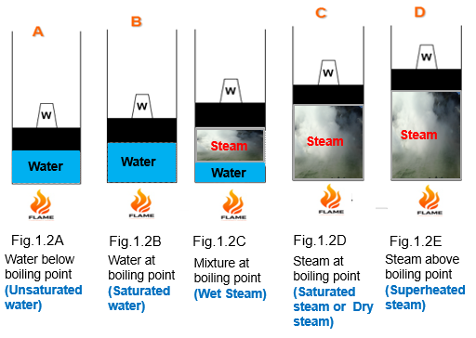

Fig. 1.2: Formation of Steam

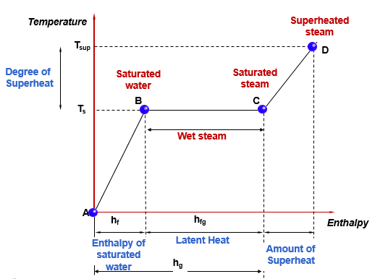

Fig.1.3: Temperature-Enthalpy Diagram

When this water is heated at constant pressure, its temperature rises till the boiling point is reached. When the boiling point of water is reached there will be a slight increase in the volume of water as shown in *Fig. 1.2 (B).* The temperature at which the water boils depends on the pressure acting on it. This temperature is called as ***saturation temperature*** and denoted as “*Ts*”*.* The heating of water from 0°C to its saturation temperature is indicated by inclined line AB in the temperature-enthalpy graph with point B depicting the saturation temperature. ***Saturation temperature****: It is defined as the temperature at which the water begins to boil at the stated pressure “P”.* The boiling temperature of the water increases with the increase in pressure at which the water is heated.

## Enthalpy of saturated water (hf):

*It is the amount of heat required to raise the temperature of 1 kg of water from 00 C to the saturation temperature Tsat* °C *at a given constant pressure “P”..*

*hf = m x Cp x Tsat kJ/kg*

*Where, m = mass of water in kg. Cp = specific heat of water*

*= 4.187 kJ/kgK*

Further addition of heat, initiates the evaporation of water while the temperature remains constant at the saturation temperature *Tsat* because at the saturation temperature water is saturated with heat and any further heat addition will only change the phase from the liquid to the gaseous phase. This evaporation continues at the same saturation temperature *Tsat* until the whole of the water is completely converted into dry steam as shown in *Fig. 1.2(D).* This constant pressure and constant temperature heat addition process is represented by the horizontal line *BC* on the temperature- enthalpy graph.

## Latent heat of vaporization or enthalpy of vaporization: (hfg)

*It is the amount of heat required to vaporize 1 kg of water at the saturation temperature Tsat into* 1 *kg of dry steam at the same saturation temperature at given constant pressure “P”.*

On heating the steam further at the same constant pressure, its temperature increases beyond the saturation temperature *Tsat.* The temperature of the steam *above* the saturation temperature at a given pressure is called *superheated temperature Tsup* . During this process of heating, the dry steam will be heated from its dry state, and this process of heating is called *superheating.* The steam when superheated is ca1led *superheated steam.* This superheating is depicted in *Fig. 1.2(E)* and is represented by the inclined line CD on the temperature- enthalpy graph.

## Amount of superheat or enthalpy of superheat:

*It is the amount of heat required to increase the temperature of dry steam from its saturation temperature to any desired higher temperature at the given constant pressure “P”. The difference between the superheated temperature and the saturation temperature is defined as*

*degree of superheat.*

*AOS = m x Csup (Tsup - Tsat)* kJ/kg

Where

*Csup* = Specific heat of superheated steam

*= 2.25 kJ/kgK*

*Tsup =* Superheated Temperature.

# Advantages of Superheated Steam

1. At a given pressure, the superheated steam possess more heat energy compared to dry saturated steam or wet steam at the same pressure, hence its capacity to do the work will be higher.
2. When superheating is done by the exhausting combustion gases in a boiler, there will be a saving of the energy of combustion which improves the thermal efficiency of the boiler.
3. While expanding in a steam turbine it reduces and in some cases prevents the condensation, thus giving better economy.

# Disadvantages of Superheated Steam

1. The high superheated temperature poses problems in the lubrication.
2. Higher depreciation and initial cost.

In the steam generation experiment the steam that is being generated exists in *three* different states namely

* 1. *Wet steam*
  2. *Dry saturated steam*
  3. *Superheated steam.*

## Wet Steam:

When the water is heated beyond the saturation state at constant pressure it starts evaporating. This evaporation process depicted in Fig. 1.2(C) is not instantaneous and during the process water exists in the form of wet steam until it completely gets converted into dry steam.

A *wet steam is defined as a two-phase mixture of entrained water molecules and steam co existing in thermal equilibrium at the saturation temperature corresponding to a given constant pressure.*

# Dryness Fraction of Steam

The quality of the wet steam is specified by a parameter called *dryness fraction* which indicates the amount of dry steam present in the given quantity of wet steam and is denoted as “*x”.*

The *dryness fraction of a steam is defined as the ratio of mass of the actual dry steam present in a known quantity of wet steam to the total mass of the wet steam.*

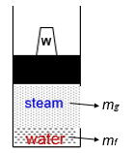

*Fig.1.4. Wet steam in a container.*

Let *mg* = Mass of dry steam present in the sample quantity of wet steam

*mf* = Mass of suspended water molecules in the sample quantity of wet steam

Dryness fraction, x

 Mass of Dry Steam present in Wet Steam Total Mass of Wet Steam

*x*  *mg*

*mf*  *mg*

The dryness fraction of wet steam is always less than 1. The dryness fraction of dry steam is equal to 1.

## Dry Saturated Steam:

Steam which is in contact with water from which it has been formed will be in thermal equilibrium with the water (i.e., the heat passing from steam into the water is balanced by the equal quantity of heat passing from the water into the steam) is said to be a *saturated steam. A saturated steam at the saturation temperature corresponding to a given pressure and having no water molecules entrained in it is defined as dry saturated steam or simply dry steam.* Since the dry saturated steam does not contain any water molecules in it, its *dryness fraction will be unity.*

## Superheated Steam:

When the dry saturated steam is heated further at the given constant pressure, its temperature rises beyond its saturation temperature. The steam in this state is said to be superheated steam *A superheated steam is defined as the steam which is heated beyond its dry saturated state to*

*temperatures higher than its saturated temperature at the given pressure.*

## Enthalpy of Dry Saturated Steam:

The *enthalpy of dry saturated steam is defined as the total amount of heat supplied at a given constant pressure to convert I kg of water into I kg of dry saturated steam at its saturation temperature. It is denoted as hg and will be equal to sum of the sensible heat hf and the latent heat of evaporation hfg.* '

***hg* = *hf* + *hfg*** kJ/kg

## Enthalpy of Wet Steam:

Since wet steam contains water molecules entrained in it, it will have absorbed only a fraction of the latent heat of evaporation proportional to the mass of the dry steam contained in the wet steam. Therefore, the *enthalpy of wet steam is defined as the total amount of heat supplied at a constant pressure to convert I kg of water at O°C into I kg of wet steam of specified dryness fraction. It is denoted as h and will be equal to sum of the sensible heat and the product of the dryness fraction and the latent heat of evaporation.*

***h* = *hf* + *x hfg*** kJ/kg

## Enthalpy of Superheated Steam:

To superheat the steam, the heat is supplied at a constant pressure to the dry saturated steam to increase its temperature beyond its saturation temperature. Therefore, the *enthalpy of superheated steam is defined as the total amount of heat supplied at a given constant pressure to convert I kg of water at 0°C into I kg of superheated steam at the stated superheated temperature.* It is denoted as *hsup and will be equal to sum of the enthalpy of dry saturated steam and the amount of superheat.* If *Tsup* is the superheated temperature, Tsat is the saturated temperature and *Csup* is the specific heat of superheated steam, then the amount of superheat will be equal to *Cps (Tsup* - *T*sat).

***hsup* = *hg* + *Csup (Tsup* - *Tsat)*** kJ/kg

# Enthalpy equations

1. *Enthalpy of Dry saturated Steam:*

***hg* = *hf +hfg*** kJ/kg

1. *Enthalpy of Wet Steam:*

***h = hf + x .hfg*** kJ/kg

1. *Enthalpy of Superheated Steam:*

***hsup = hf + hfg + Csup (Tsup - Tsat)*** kJ/kg

1. *Degree of superheat (DOS):*

***DOS = (Tsup - Tsat)*** *0C*

1. *Amount of superheat (AOS):*

***AOS = Csup (Tsup - Tsat)*** kJ/kg

# Critical Temperature & Pressure

At a particular pressure water is directly converted into dry steam without going through the phase of vaporization. i.e, hfg = 0. This point is called critical point and pressure and temperature at that point are called Critical pressure (Pc) and Critical temperature(Tc).

Pc = 221.2 bar Tc = 374.150C

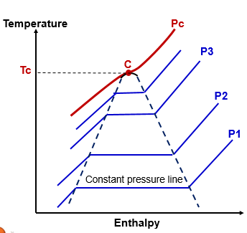

* *Boiling will not happen* ***at and above*** *critical point.*
* *At the critical point, only gaseous exists.*

Critical pressure:

It is the pressure at which the water is directly converted into dry steam without undergoing the state of vaporization.

Critical temperature:

It is the corresponding temperature at the critical point above which water exists only as vapor and never as liquid.

******